**Simulation-2**

**Aim: Application of MATLAB for the design of single-phase dual converter.**

**Software Required**

* MATLAB SIMULINK

**Theory:**

**What is a dual converter?**

As the name suggests Dual Converter has two converters, one converter works a rectifier (Converts AC to DC) and another converter works as an inverter (converts DC into AC). Both converters are connected back to back with a common load.

**Single phase dual converter:**

The circuit diagram of the dual converter is shown in the below figure. A separately excited DC motor is used as a load. The DC terminals of both the converters are connected with the terminals of the armature winding. Here, two single-phase full converters are connected back to back. Both converters supply a common load.

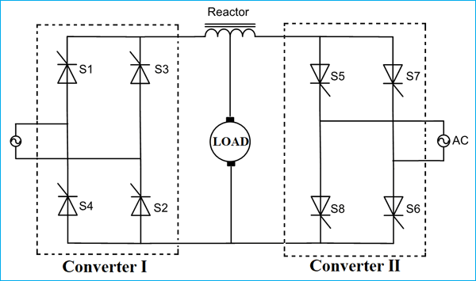

*Fig 1- Circuit of Single-phase dual converter.*

The firing angle of converter-1 is α1 and α1 is less than 90˚. Hence, the converter-1 act as a rectifier. For positive half cycle (0 < t < π), thyristor S1 and S2 will conduct and for a negative half cycle (π < t < 2π), thyristor S3 and S4 will conduct. In this operation, output voltage and current both are positive. So, this operation is known as forward motoring operation and the converter works in the first quadrant.

The firing angle of converter-2 is 180 - α1 = α2 and α2 is greater than 90˚. So, converter-2 act as an inverter. In this operation, the load current remains in the same direction. The polarity of the output voltage is negative. Therefore, the converter works in the fourth quadrant. This operation is known as regenerative braking.

For reverse rotation of DC motor, converter-2 act as rectifier and converter-1 act as an inverter. The firing angle of converter-2 α2 is less than 90˚. The alternative voltage source supplies the load. In this operation, the load current is negative and the output average voltage is also negative. Therefore, the converter-2 works in the third quadrant. This operation is known as the reverse motoring.

In reverse operation, the firing angle of converter-1 is less than 90˚ and firing angle of converter-2 is greater than 90˚. So, in this operation, the load current is negative but the average output voltage is positive. So, the converter-2 works in the second quadrant. This operation is known as the reverse regenerative braking.

**Procedure:**

* Firstly, MATLAB Simulink interface should be opened.
* Once, the Simulink is opened, one should open the power libraries in MATLAB.
* Once, the libraries are opened, a MOSFETs, AC voltage source, Resistors, Thyristors, Voltage measurement, Pulse generator, scope and Power Gui are chosen for designing a Single phase dual converter.
* The parameters of the above components are set to the needs of this simulation.
* All the above components are connected accordingly.
* After the connections are done, the circuit is simulated. For the output of the Single-phase dual converter, scope should be pressed. The scope is connected with the three Voltage measurements.
* The output waveforms are obtained through the Scope.

**Circuit Simulated in MATLAB**

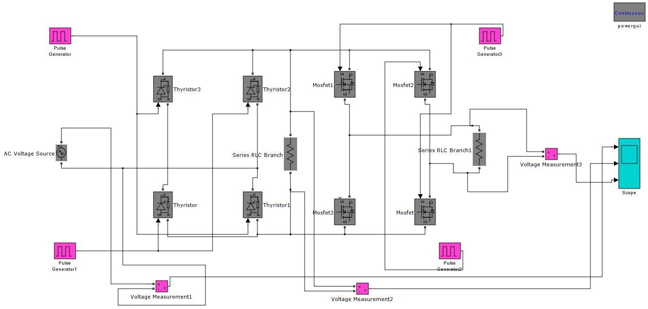

*Fig 2: Simulink Circuit of Single-phase Dual Converter*

**Output Waveforms obtained:**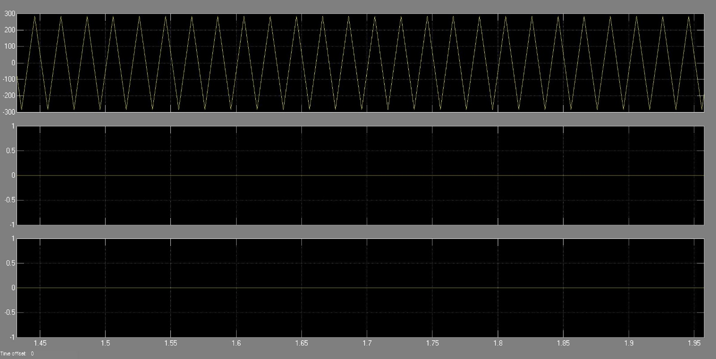

*Fig 3: Simulink scope output of Single-phase dual converter.*

**Result:** The output of Single-phase dual converter has been obtained in MATLAB Simulink and the result has been verified.